17.97: a) Replacing m with nM and nMc with nC,
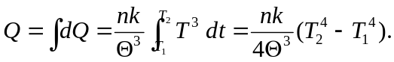
For the given temperatues,
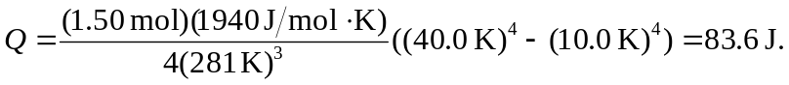
b) 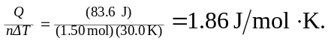
c)

